# ABOUT US

Over the last three years, *Night of Fortresses* event has connected more than 50 sites in 8 countries and 40 cities, including coastal and inland fortresses, castles, museums, galleries, and fortified towns, promoting them as tourist attractions. This success showed the potential for stronger cooperation in the development of sustainable cultural tourism.

### The organizers are announcing a new edition of the event, **Night of Fortresses Goes Green**, set to take place on **Friday, May 9, 2025**!

### OBJECTIVE

**The idea is simple:** connect cultural heritage with ecological responsibility! The goal is to raise visitor awareness about sustainable tourism and practices and to encourage active participation in environmental protection.

Through **Night of Fortresses Goes Green**, we are not only celebrating cultural heritage but also contributing to the protection of our planet – step by step, event by event.

All heritage site managers, cultural institutions, and fortified locations across Europe are welcome to join Night of Fortresses Goes Green. However, registered programs must include a green component.

Organizers are encouraged to create activities such as open days, guided tours, lectures, workshops, exhibitions, concerts, dance performances, and other events that promote sustainable practices, environmental responsibility, and the preservation of cultural heritage.

**READY TO GET INVOLVED? HERE IS HOW….**

# REGISTRATION AND PROCEDURE?

Online registration are open until

**26th April 2025**

**REGISTER** your event with a simple questionnaire on the Night of Fortress Goes Green website ([https://nightoffortresses.org/hr](https://nightoffortresses.org/hr/forma-za-prijavu-2024/)/)



**REGISTRATION**

You will be asked for the following information:

1. Country
2. City
3. Event venue adress
4. Organiser
5. Short event description

Original language and English (250 characters per language)

1. Web site and social media accounts (for reposting)
2. Venue photo

Hi-res photo; copyright

1. Contact

Registration for **Night of Fortresses Goes Green** is free for organizers, and all programs within the event must be accessible to visitors **free of charge**.

If the programs have a limited number of spots, please clearly specify the registration process for visitors in the program description.

# why ?

The cultural sector has a unique opportunity and responsibility to act as a catalyst for change in society, especially in promoting sustainable practices and raising ecological awareness. By organizing "green" events, managers of cultural sites can achieve multiple benefits:

• **Education and raising awareness**: Cultural events provide an opportunity to educate the public about the importance of environmental protection. Through creative programs, visitors can learn about ecological challenges and sustainable practices, encouraging more responsible behavior toward nature.

• **Preservation of cultural heritage**: Sustainable practices in event organization contribute to preserving cultural sites for future generations. By applying environmentally friendly technologies and reducing negative environmental impacts, cultural heritage becomes more resilient and lasting.

• **Connecting with the local community**: Involving the local community in organizing and participating in events strengthens social cohesion and joint efforts toward sustainability. Local initiatives, such as recycling workshops or cleanup actions, encourage a sense of togetherness and shared responsibility.

• **Economic development**: Sustainable cultural events can attract environmentally conscious tourists, stimulating the local economy. Promoting local products and services reduces the ecological footprint and supports the sustainable development of destinations.

• **Inspiration for change**: Culture has the power to inspire and encourage changes in society. Through artistic expression and cultural events, it is possible to raise public awareness of environmental issues and motivate active participation in environmental protection.

To support the organization of more sustainable cultural events, the Night of Fortresses Goes Green team has prepared a collection of examples and useful guidelines, available on the event's official website.



**EXAMPLES!**

# FOR YOU TO DO

### PROMOTE YouR EVENT

* on your website and social media & use hashtags

**#nightoffortresses #EuropeanFortressSummer #noctvrdava**

**#ForteCultura #Effortseurope**

* use Night of Fortress Goes Green logo
* Announce the event to educational institutions, tourist boards, other stakeholders in culture, local self-government units and, of course, the media.

### tell us how it was!

By the **13th of May**, send us an e-mail (vera@tvrdjava-kulture.hr) with the number of visitors and all interesting photos /video of your event.



Upon completion of the application process, your event will be presented on:

* Night of Fortresse website <https://nightoffortresses.org>

# PARTICIPANTS KIT

## **MANDATORY USE OF LOGOS AND #hashtags!**

### night of fortress GOES GREEN LOGO

(You will find the logos for download on: <https://nightoffortresses.org/>)

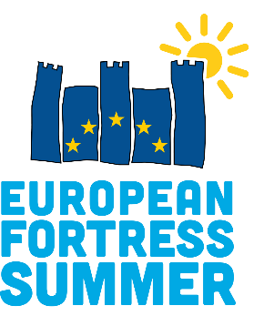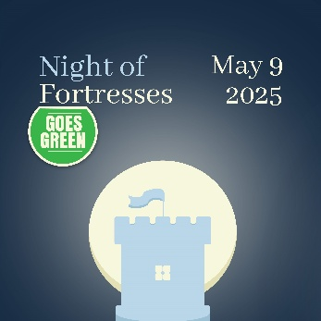



**TOOL KIT!**

### HASHTAGS



**#** **NightOfFortressesGoesGreen**

**#noctvrdava**

### content and tehnical tips

* High quality/ resolution pictures and videos
* Consider privacy protection & copyrights
* Use *storytelling*
* Involve the audience
* Present yourself
* Use # list
* Promote your event on social media and other chanells of communication

# your team

|  |  |  |
| --- | --- | --- |
| Vera Jergović Bolanča | [vera@tvrdjava-kulture.hr](mailto:vera@tvrdjava-kulture.hr) | JUK Tvrđava kulture Šibenik/CRO |
| Davorka Radović | [davorka.radovic@karlovac.hr](mailto:davorka.radovic@karlovac.hr) | Grad Karlovac/CRO |
| Ana Vučević | [ana.vucevic@bar.me](mailto:ana.vucevic@bar.me) | Opština Bar/MNT |
| Ilmira Lika | [ilmira.lika@ul-gov.me](mailto:ilmira.lika@ul-gov.me) | Opština Ulcinj/MNT |
| Maja Lukač Marjanović | [maja.l.marjanovic@banjaluka.rs.ba](mailto:maja.l.marjanovic@banjaluka.rs.ba) | Grad Banja Luka/BiH |
| Simo Radić | [muzejherc@gmail.com](mailto:muzejherc@gmail.com) | Grad Trebinje/BiH |